How to Write a Research Proposal

Authors:
Kevin Omondi, Tiberius Tabulu, Titus Kipkosgei Tunduny and Benjamin Mundama
Designed for Final Year Scientific Research Projects in ICS, BBIT and CNS for the School of Computing and Engineering Sciences

Summary
The Research Proposal is always written in third person, and it has three Chapters namely, Introduction, Literature Review and Methodology. In this guide, we analyze and give a detailed overview of each of these major sections and the rest of the subsections not highlighted in this overview.
Note: Some sections of the proposal that usually appear on the writeup such as Cover Page (includes the Title of the Research), Declaration and Approval, Table of Contents, List of Tables, Figures, Equations and Abbreviations will be elaborated in detail during the class seminars [Refer to the Template Provided on Classrooms,]. You may use the template to start your writeup

Cited References
- How to write the Background of your study - Dr. Rishibha Sachdev

Acknowledgement(s)
The acknowledgement for thesis/proposal is the section where you thank all people, institutions, and companies that helped you complete the project successfully. It is similar to a dedication, except for the fact that it is formal. Also, you don’t need to mention every single person who helped you with the research - just those who were most important to your research. For example, you don’t need to thank your boyfriend/girlfriend for making you dinner as you worked on the project.

Abstract
An abstract is a condensed version of a longer piece of writing that highlights the major points covered, concisely describes the content and scope of the writing, and reviews the writing's contents in abbreviated form. Abstracts are typically 100 to 250 (but usually 200) words and follow set patterns; some of these patterns can be set by the examining academic institution. In some cases, the abstract forms the reader’s initial impression of the work, and therefore plays a big role on whether the application is funded. The abstract speaks for the proposal when it is separated from it, provides the reader with his or her first impression of the request, and, by acting as a summary, frequently provides the reader their last impression. Some reviewers read only the abstract, e.g., a foundation board of directors’ member who votes on final funding decisions. Thus it is the most important single element in the proposal.

Importance of the Abstract
- Help readers decide if they should read an entire article
- Help readers and researchers remember key findings on a topic
- Help readers understand the text by outlining key points prior to reading the full document
- Index articles for quick recovery and cross-referencing

Key Elements of an Abstract
- Background: A simple opening sentence or two placing the work being investigated in context.
- Aims: One or two sentences giving the purpose of the work being investigated.
- Method(s): One or two sentences explaining what was (or will) be done during the course of the project.
- Results: One or two sentences indicating the main findings (or what you hope to accomplish with the project). In most cases, this is edited and put into context at the final stages of the project, for example, one might include the accuracies of the model or the improvements realized.
- Conclusions: One sentence giving the most important consequence of the work – what do the results mean? Are they solving anything? How will they be used?

Questions an Abstract Should Answer
The author should consider the following.
- Why did you do this study/Research or project? Remember the author is always encouraged to start with the end in mind. The end might include graduating as part of the reasons.
- What did you do, and how? (What will you do? How?). What did you find? (What do you expect to find?). What do the findings mean?

Tips When Constructing an Abstract
- Reread your article or proposal with the goal of abstracting in mind.
  - Look specifically for these main parts of the article or proposal: purpose, methods, scope, results, conclusions and recommendations.
  - Use the headings and table of contents as a guide to writing your abstract.
- After you've finished rereading the article or proposal, write a rough draft without looking back at what you're abstracting.
  - Don't merely copy key sentences – you'll put in too much or too little information.
  - Don't rely on the way material was phrased – summarize information in a new way.
- Revise your rough draft to:
  - Correct weaknesses in organization
  - Improve transitions from point to point
  - Drop unnecessary information
  - Make sure it is complete and accurate
  - Eliminate wordiness
  - Fix errors in grammar, spelling and punctuation
  - Make sure it’s written in the same voice as the paper
Class Todo:
- From your proposed research title, construct a 250 word draft abstract/ concept note and discuss it with your supervisor.
- To get ideas, read a the sample Abstract from the Research papers: OkwuGbé: End-to-End Speech Recognition for Fon and Igbo or Machine Learning: Algorithms, Real-World Applications and Research Directions

Chapter 1: Introduction
The introduction is the part of the paper or proposal that provides readers with the background information for the research reported in the paper/proposal. Its purpose is to establish a framework for the research, so that readers can understand how it is related to other research (Wilkinson, 1991, p. 96). Other research can be found from related literature.
In some cases, where funding is needed, writing an effective research proposal is essential. The introduction, being the first part of your proposal, must provide the funders a clear understanding of what you plan to do. A well written introduction will help make a compelling case for your research proposal.
To begin with, overall, the introduction must set context for your research by mentioning what is known about the topic and what needs to be explored further. In the introduction, you can highlight how your research will contribute to the existing knowledge in your field and to overall scientific development.
The introduction must also contain a hypothesis that led to the development of the research design. You can come up with this hypothesis by asking yourself questions like:
- What is the central research problem?
- What is the domain of study related to that problem?
- What methods should be used to analyze the research problem?
- Why is this research important, what is its significance, and how will its outcomes affect the funders and the research society as a whole?

Sections of Chapter 1
Below are the sections of chapter 1 in a research proposal.

1.1 Background Information
The background of the study establishes the context of the research. This section explains why this particular research topic is important and essential to understanding the main aspects of the study. Usually, the background forms the first section of a research proposal/ article/thesis and justifies the need for conducting the study and summarizes what the study aims to achieve.

How Should the Background Information Be Structured?
The author usually outlines the historical developments in the literature that led to the current topic of research concisely. If the study is interdisciplinary, it should describe how different disciplines are connected and what aspects of each discipline will be studied. In this case, the major research discipline is in technology, therefore, specific research areas in technology can be mentioned and related.
Additionally, authors should briefly highlight the main developments of their research topic and identify the main gaps that need to be addressed. In other words, this section should give an overview of your study. The section should be organized as:
- What is known about the broad topic?
- What are the gaps or missing links that need to be addressed?
- What is the significance of addressing those gaps?
- What are the rationale and hypothesis of your study?

How to make the Background Engaging
Since this section usually has a lot of information, it can become a long drag, causing the readers and funders in some cases to lose interest. To ensure that your background is engaging, you should try to build a story around the central theme of your research.
Ensure that the story adheres to the core idea and does not digress into a broad literature review. Each idea should lead to the next so that readers are able to grasp the story and themselves identify the gaps that your study is going to address.
Class Discussion: [Assuming you are conducting research on Sentiment Analysis on Twitter data, what aspects would you consider?]

How To Avoid Common Mistakes In Writing The Background.
While writing an effective background, you ought to steer clear of some mistakes. The most common mistakes in writing the background include the following:
- Don’t write a background that is too long or too short. Focus on including all the important details but write concisely.
- Don’t be ambiguous. Writing in a way that does not convey the message to the readers defeats the purpose of the background, so express yourself keeping in mind that the reader does not know your research intimately.
- Don’t discuss unrelated themes. Try and center your discussion around the pivotal aspects of your research topic i.e. highlight the gaps in the literature, state the novelty of the study, and the need to conduct the study.
- Don’t be disorganized. Not discussing the themes in a chronological manner can confuse the reader about the progress in the field, so try and organize your writing carefully.

Background Information is NOT Literature Review
Many authors find it difficult to discern the difference between the literature review and the study background. The literature review section should follow the background section, especially the specific objectives, as the second section of your thesis or research paper. This section basically supports the background section by providing evidence for the proposed hypothesis. This section should be more comprehensive and thoroughly describe all the studies that you have mentioned in the background section. It should also elaborate on all studies that form evidence for the present study and discuss the current trends.
In background information, you will need to do a thorough literature search on different studies that relate to the broad topic of your research. This will introduce the readers to the area of your research. Following this, you should present a more focused survey of the specific studies that are associated with the precise objective of your study. It would be ideal to organize them thematically and discuss them chronologically so that readers are aware of the evolution and progress in the field. In other words, separate themes should be discussed chronologically to highlight how research in those fields has progressed over time. This will highlight what has been done and what are the future directions that need to be worked upon.
Note: Information in this section should be heavily referenced especially when making citations or quoting facts from other sources.

1.2 Problem Statement
A statement of the problem is used in research work as a claim that outlines the problem addressed by a study. The statement of the problem briefly addresses the question: What is the problem that the research will address?

Goals of a Problem Statement
The ultimate goal of a statement of the problem is to transform a generalized problem (something that bothers you; a perceived lack) into a targeted, well-defined problem; one that can be resolved through focused research and careful decision-making.
Writing a statement of the problem should help you clearly identify the purpose of the research project you will propose. Often, the statement of the problem will also serve as the basis for the introductory section of your final proposal, directing your reader’s attention quickly to the issues that your proposed project will address and providing the reader with a concise statement of the proposed project itself.

A statement of problem need not be long and elaborate: one page is more than enough for a good statement of problem, though that is for the advanced levels. In some cases, a paragraph with about 150 words is sufficient.
Note. Adding references on the research problem statement is highly recommended especially when citations are done.

Characteristics of a Good Research Problem Statement
- Should address a gap in knowledge given that you have already had some background through the literature you have read.
- Should be significant enough to contribute to the existing body of research
- Should lead to further research, future work that can be explored. No solution is ever sufficient
- The problem should render itself to investigation through collection of data. In technical scientific research, the investigation is mostly done through experiments.
- Should be of interest to the researcher and suit his/her skills, time, and resources. Remember having the end goal in mind, this includes graduating on time as well.
- The approach towards solving the problem should be ethical. The core reason for research is always to make the world a better place.

What then is the format for writing a good problem statement?
A persuasive statement of problem is usually written in three parts:
- The ideal part: Describes a desired goal or ideal situation; explains how things should be.
- The reality part: Describes a condition that prevents the goal, state, or value in Part A from being achieved or realized at this time; explains how the current situation falls short of the goal or ideal.
- The consequences part: Identify the way you propose to improve the current situation and move it closer to the goal or ideal.

1.3 Objectives
Research objectives are the goals to be achieved by conducting the research. They may be stated as general and specific.

1.3.1 General Objective
The general objective of the research is what is to be accomplished by the research project, for example, to develop an end to end speech recognition model for Fon and Igbo.

1.3.2 Specific objectives
The specific objectives relate to the specific research questions the investigator wants to answer through the proposed study and may be presented as primary and secondary objectives, for example, primary: To determine the effectiveness of models trained using unsupervised learning by benchmarking with gold standard supervised models. Secondary: To study the cost effectiveness and implications of using unsupervised learning.

Points to Note:
Researchers are advised to resist the temptation to put too many objectives or over-ambitious objectives that cannot be adequately achieved by the implementation of the protocol.
Objectives are typically numbered, so each one stands alone. Each objective must have a concrete method defined since they will help you in formulating your chapter 2. If you're having trouble developing concrete objectives and methods, writing out a research timeline before defining your objectives may help.
Use Roman numerals when numbering your objectives and start with the key word To in a research Proposal. Additionally, your objectives should be SMART
- Specific - prepare yourself for in-depth research about the issue you want to address. Avoid general statements such as “this project will improve the models accuracy”.
- Measurable - Keep in mind that your supervisor wants to know how the success of your project can be evaluated. Therefore your objectives must enable the supervisor to monitor the progress of the project and assess the final results.
- Achievable - Set achievable targets; do not claim that a yearlong project will produce radical change. Rather, set clear objectives that can be fulfilled.
- Relevant - This can also mean results oriented. Your project objective should be able to answer the questions like “why should this project be done?” “What impact will this project have?”
- Time - Related - Remember your objectives must be reached in a set time-frame. Draw on the results of similar projects and observe what is happening in your research community in order to decide how long it will take to complete a task. Also, you have a fixed timeline in which you will want to graduate after.
For Example: Assuming your topic is An Artificial Neural Network Model to Classify the Severity of Cholera Outbreaks in Kenya, then the some of the objectives could be:
i. To study the challenges faced by the Kenyan government in predicting Cholera outbreaks
ii. To investigate existing cholera disease outbreak and severity classification models
iii. To review the various development technologies for the outbreak severity classification model
iv. To develop an artificial neural network model to classify the severity of cholera outbreaks in Kenya.
v. To test the proposed model

1.4 Research Questions
A research question is the specific concern that you will answer through your research. It is derived from your research problem but is based on your study design. When you narrow down your research problem to a specific idea that points towards a feasible way to investigate or address your research problem, you get your research question. Most of the time, your research questions point to your objectives and are generated from them.
Some of the questions from the objectives could be (sample only):
- What are the challenges faced by the Kenyan Government in predicting cholera outbreaks? What is an outbreak?
- What models exist that are used in determining outbreak severity/ outbreak classification?
- Are there existing systems/ models/ techniques/ technologies used to classify outbreak severity? How do those systems work/ operate?
- Which tools can be used to develop the cholera outbreak severity classification model for the Kenyan context? How will the model/ system work? What data will be used in the model?
- How will the proposed system be designed and developed?- which languages will be used and why, which tools , where will the data be derived from?
- How will the developed system/ model be tested?
Class Group Discussion: [Identify Objectives for your study/ one of your problem(s) and Derive Research questions for the objectives]

1.5 Justification
The rationale or justification for doing any research must be drawn from the existing literature on the subject. You will need to conduct a thorough literature survey and identify gaps in the current literature. The best way to write this is to introduce the current literature in the background/Introduction section and then highlight the gaps in the literature that have not been addressed or are yet to be understood. This will help set up the need for the current study and thus justify the need for this research. This section should be heavily cited from the literature or relevant sources.

1.6 Scope and Delimitations
The scope details how in-depth your study is to explore the research question and the parameters in which it will operate in relation to the population and timeframe.
The delimitations of a study are the factors and variables not to be included in the investigation. In other words, they are the boundaries the researcher sets in terms of study duration and the technologies applied.

Difference Between Delimitations and Limitations
Delimitations refer to the boundaries of the research study, based on the researcher’s decision of what to include and what to exclude. They narrow your study to make it more manageable and relevant to what you are trying to prove.
Limitations relate to the validity and reliability of the study. They are characteristics of the research design or methodology that are out of your control but influence your research findings. Because of this, they determine the internal and external validity of your study and are considered potential weaknesses.
In other words, limitations are what the researcher cannot do (elements outside of their control) and delimitations are what the researcher will not do (elements outside of the boundaries they have set). Both are important because they help to put the research findings into context, and although they explain how the study is limited, they increase the credibility and validity of a research project.

How to Start Writing Your Study Scope
Use the below prompts as an effective way to start writing your scope:
- This (proposed) study is to focus on…
- This (proposed) study covers the…
- This (proposed) study aims to…

Guidelines on How to Write Delimitations
Since the delimitation parameters are within the researcher’s control, readers need to know why they were set, what alternative options were available, and why these alternatives were rejected. For example, if you are collecting data that can be derived from three different but similar experiments, the reader needs to understand how and why you decided to select the one you have.
Your reasons should always be linked back to your research question, as all delimitations should result from trying to make your study more relevant to your scope. Therefore, the scope and delimitations are usually considered together when writing a paper.

How to Start Writing Your Study Delimitations
Use the below prompts as an effective way to start writing your study delimitations:
- This study does not cover…
- This study is limited to…
- The following has been excluded from this study… with relevant reasons.

Examples of Limitations in Research
Note: You may put this section in 1.7

Examples of limitations include:
- Issues with sample (dataset/IoT Devices) and selection,
- Insufficient sample size, dataset, population traits or specific participants for statistical significance,
- Lack of previous research studies on the topic which has allowed for further analysis,
- Limitations in the technology/instruments used to collect your data,

Chapter 2: Literature Review

Points to Note
A literature review surveys books, scholarly articles, and any other sources relevant to a particular issue, area of research, or theory, and by so doing, provides a description, summary, and critical evaluation of these works in relation to the research problem being investigated. Literature reviews are designed to provide an overview of sources you have explored while researching a particular topic and to demonstrate to your readers how your research fits within a larger field of study.

Importance of a Good Literature Review
A literature review may consist of simply a summary of key sources, but in the social sciences, a literature review usually has an organizational pattern and combines both summary and synthesis, often within specific conceptual categories. A summary is a recap of the important information of the source, but a synthesis is a reorganization, or a reshuffling, of that information in a way that informs how you are planning to investigate a research problem. The analytical features of a literature review might:
- Give a new interpretation of old material or combine new with old interpretations,
- Trace the intellectual progression of the field, including major debates,
- Depending on the situation, evaluate the sources and advise the reader on the most pertinent or relevant research, or
- Usually in the conclusion of a literature review, identify where gaps exist in how a problem has been researched to date.

The Purpose of a Literature Review is to:
- Place each work in the context of its contribution to understanding the research problem being studied.
- Describe the relationship of each work to the others under consideration.
- Identify new ways to interpret prior research.
- Reveal any gaps that exist in the literature.
- Resolve conflicts amongst seemingly contradictory previous studies.
- Identify areas of prior scholarship to prevent duplication of effort.
- Point the way in fulfilling a need for additional research.
- Locate your own research within the context of existing literature [very important].

The structure of a literature review should include the following:
- An overview of the subject, issue, or theory under consideration, along with the objectives of the literature review,
- Division of works under review into themes or categories [e.g. works that support a particular position, those against, and those offering alternative approaches entirely],
- An explanation of how each work is similar to and how it varies from the others,
- Conclusions as to which pieces are best considered in their argument, are most convincing of their opinions, and make the greatest contribution to the understanding and development of their area of research.

The critical evaluation of each work should consider:
- Provenance -- what are the author's credentials? Are the author's arguments supported by evidence [e.g. primary historical material, case studies, narratives, statistics, recent scientific findings]?
- Methodology -- were the techniques used to identify, gather, and analyze the data appropriate to addressing the research problem? Was the dataset size appropriate? Were the results effectively interpreted and reported?
- Objectivity -- is the author's perspective even-handed or prejudicial? Is contrary data considered or is certain pertinent information ignored to prove the author's point?
- Persuasiveness -- which of the author's theses are most convincing or least convincing?
- Value -- are the author's arguments and conclusions convincing? Does the work ultimately contribute in any significant way to an understanding of the subject?

Writing Your Literature Review
Once you've settled on how to organize your literature review, you're ready to write each section. When writing your review, keep in mind these issues.

- Use Evidence - A literature review section is, in this sense, just like any other academic research paper. Your interpretation of the available sources must be backed up with evidence [citations] that demonstrates that what you are saying is valid.
- Be Selective - Select only the most important points in each source to highlight in the review. The type of information you choose to mention should relate directly to the research problem, whether it is thematic, methodological, or chronological.
- Summarize and Synthesize - Remember to summarize and synthesize your sources within each thematic paragraph as well as throughout the review.
- Keep Your Own Voice - While the literature review presents others' ideas, your voice [the writer's] should remain front and center.
- Use Caution When Paraphrasing - When paraphrasing a source that is not your own, be sure to represent the author's information or opinions accurately and in your own words. Even when paraphrasing an author’s work, you still must provide a citation to that work.

Common Mistakes to Avoid in Literature Review
These are the most common mistakes made in reviewing social science research literature.
- Sources in your literature review do not clearly relate to the research problem;
- You do not take sufficient time to define and identify the most relevant sources to use in the literature review related to the research problem;
- Uncritically accepts another researcher's findings and interpretations as valid, rather than examining critically all aspects of the research design and analysis;
- Only includes research that validates assumptions and does not consider contrary findings and alternative interpretations found in the literature

Class Discussions: How to Structure Chapter 2
In this section, we will draw our own conclusions from a sample topic and its objectives. Assuming you have a topic such as [To Be Determined]
You will need to have sample objectives as below. (These are just examples, you will need to work very close to your supervisor and come up with the right ones, but generally, this is the format)
Sample Specific Objectives
- To Study and analyze the state of Hate speech on social media
- To investigate and analyze challenges associated with hate speech on social media
- To investigate and analyze how hate speech detection has been done in the past
- To study and analyze challenges facing hate speech detection
- To design and develop a transformer neural network model that can detect hate speech on social media
- To test and validate the proposed model - usually addressed in Chapter 5
Sample Specific Objectives 2

- To investigate Network parameters that can be used in security modeling
- To review the operations of attack graphs and misuse case diagrams
- To review related works
- To design an novel architecture for heterogeneous networks
- To create/deploy an emulation of / a small scale enterprise network
- To model intrusions paths using attack graphs and misuse case diagrams on the deployed network
- To test the correctness of the representation of the security model
- To document…
- To determine the accuracy of graph based models in network modeling
- To analyze the complexity of attack graphs in the network security models

Points to Note:
The formulation of Chapter two is based on the structure of your objectives and therefore will differ from one person to another. Some of the objectives are therefore always combined for example, objectives one and two can be combined into one section such as in subchapter 2.2.

2.1 Discussions
This section introduces Chapter 2 and it covers how the chapter has been planned, what related works have been reviewed and generally the layout of the chapter.

2.1 Introduction
2.2. Objective 1 [Hate Speech of Social Media]
- Hate Speech on Social media
2.2.1. Challenges associated with hate speech
2.3. Related Works
Some of the related works in hate speech der…
2.3.1 Public Policies X Hate Speech detection using CNNs
2.3.2. (talk about technologies implemented, how they have been implemented, some accuracies in case of any, some benchmarks, tables of comparison of results, identify the gaps in this study.)
2.3.3 Another technology. []
2.4 Gaps in related works
2.5 Conceptual Framework

For example: Sample Topic
Hate Speech detection model using transformer Neural Networks: A case of Amharic
Objectives
- To Study and analyze the state of Hate speech on social media
- To investigate and analyze challenges associated with hate speech on social media
- To investigate and analyze how hate speech detection has been done in the past
- To study and analyze challenges facing hate speech detection
- To design and model….
- To test and validate the proposed model (addressed in chapter 5)

Find out, To review, To study,

Chapter 3: Methodology

3.1 Introduction
This section shows the chapter’s outline and summary. You will state how the chapter has been arranged and what contents have been covered in those sections. You need to be as brief as possible in this section as it is not forming the main part of the chapter.

3.2 Methodology

Discuss the choice of the methodology here, this can include the development of the solution in question. You can choose the methodology such as Agile then you must narrow down the specific methodology in this category as there are many. Another methodology can be Design Thinking and many more.

Justification of the Methodology
- You will need to provide the rationale for the chosen methodology. Remember to provide references here from the consulted literature.

Methodology Diagram
- With references, you will present the diagram here after which you will discuss and apply the methodology stages to the project.
  - For example: Design Thinking
  - For example: Prototyping.

Design Thinking - As example 1
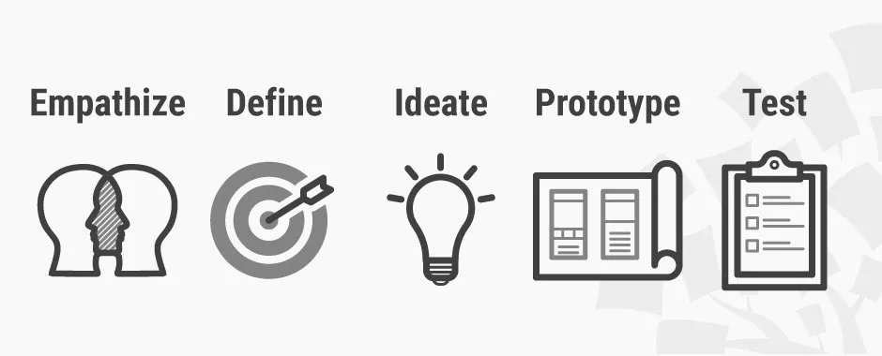

3.2.1 Empathize
Define what this is and why it is important.
- Review user problems based on secondary data.

3.2.2 Define
Define what this is and why it is important.
- Define key model/solution parameters or considerations from secondary data

3.2.3 Ideate
Define what this is and why it is important.
- Design approach and why it is important
- Possible ways of looking at the proposed solution
You will mention the design paradigm that you have chosen for your project here. This will affect how you draw your diagrams so you also have to mention the reason as to why the selected design paradigm has been chosen.
The table below should guide you on what diagrams you will be expected to use in Chapter 4 based on the design paradigm you have chosen.
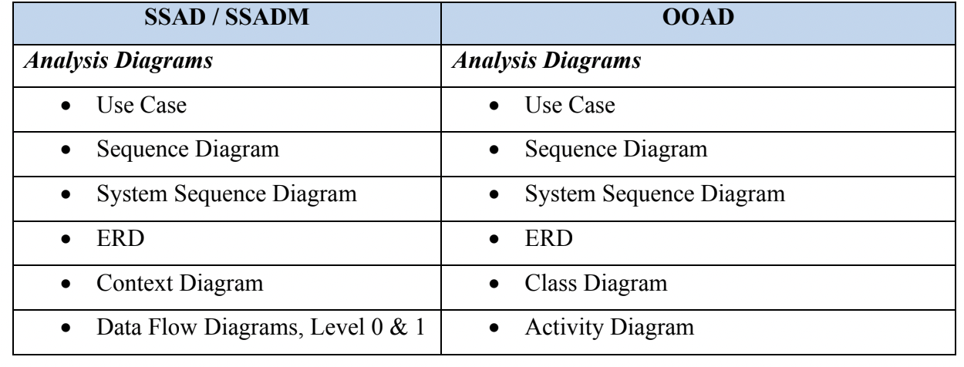
Read more about SSAD/SSADM and OOAD (article 1) and (article 2) but you can find other sources to read more on this.

- Analysis and Design diagrams to draw and why?

3.2.4 Prototype
Define what this is and why it is important.
- Development approach
- Development tools and techniques and why?

3.2.5 Test
Define what this is and why it is important.
- Testing approaches and why?
  - Unit testing, blackbox testing, whitbox testing
- Testing types and scenarios
  - Accuracy testing, model prediction performance
- Test cases to be drawn

Prototyping - As example 2

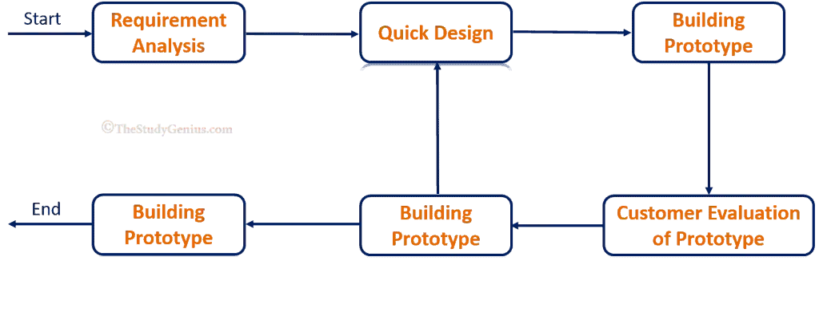

3.2.1 Requirements Gathering
Define what this is and why it is important.
- Gathering requirements, specify the use of primary and secondary sources of data.

3.2.2 Quick Design
Define what this is and why it is important.
- Preferred approach to approach and development
- Analysis and Design diagrams and why

3.2.3 User Evaluation
Define what this is and why it is important.
- Testing for Individual models and prototype
- Testing type and why

3.2.4 Refining Prototype
Define what this is and why it is important.
- Development approach
- Development tools and why - you can mention the various tools and techniques in this section.

3.2.5 Implement and Test
Define what this is and why it is important.
- This section can be theoretical, out of scope.

3.3 Deliverables
As subtopics, list and explain the deliverables that will be realized during this project and why they are important.
- Model and user interface - explain why they are important and their uses
- Proposal - discuss this in details
- Distributed system that can be used to access the applications.

3.4 Tools and Techniques
As subtopics, list and explain the tools and techniques that will be used during this project and why they are important.

Points to Note:
In case the design and analysis sections are evaluated independently, they can be outlined and discussed in sections 3.3 and 3.4 respectively and cross referenced in the methodology stages that point to analysis and design.
Such that:
- 3.3 Analysis diagrams
- 3.4 Design Diagrams
- 3.5 Deliverables
- 3.6 Tools and techniques
End of Chapter 3
Analysis and Design diagrams for ML Solutions
- Models cannot stand alone.
- Usually, to access and use a model, you will need to deploy the model into some server, or APIs to access it. Therefore, the Analysis and Design Diagrams will show how your application should be built and how different modules will interact with the model or specific parts of the system.

References:
You will have references listed according to APA referencing. This should appear automatically when you did the right thing from the beginning.
- Avoid non dated references, websites and non academic references such as Wikipedia.
- It is recommended that you use tools such as Zotero, Mendley and other similar tools.

Appendices
Definition. An appendix contains supplementary material that is not an essential part of the text itself but which may be helpful in providing a more comprehensive understanding of the research problem or it is information that is too cumbersome to be included in the body of the paper.
- Additional images that could be used to show more information in the literature review can be put there and cross referenced in the main sections. .
- Gantt Chart showing your work plan till the end of the project. Use relevant tools that can draw better conclusions from the work plans that you have.
  - Project will end at the end of November 2022 [presentations after exams]
  - You can use Google Sheets, just introduced timelines. Check it out.
- Create a numbering system that shows Appendix as a prefix.
  - Appendix 1. Appendix 2 and so on
    - Eg. Appendix 1: Gantt Chart
    - Eg, Appendix 2: Feature Extraction in CNN

Chapter 4: System Analysis and Design

4.1 Introduction
Talk about what the chapter is about, what is covered in different sections and what analysis and design diagrams you have drawn, you can also recap on the design paradigm that you have used for instance OOAD or SSAD/SSADM.

4.2 System Requirements
System requirements are the configuration that a system must have in order for a hardware or software application to run smoothly and efficiently. Failure to meet these requirements can result in installation problems or performance problems. The former may prevent a device or application from getting installed, whereas the latter may cause a product to malfunction or perform below expectation or even to hang or crash.
You may start by writing:- Some of the system requirements reviewed in the project include:

4.2.1 Functional Requirements
These are product features or functions that developers must implement to enable users to accomplish their tasks. So, it’s important to make them clear both for the development team and the stakeholders. Generally, functional requirements describe system behavior under specific conditions. For example:
- The system sends an approval request after the user enters personal information in the requirements and in the login section.
- A search feature allows a user to hunt among various invoices if they want to credit an issued invoice. This can also be applied to the catalog.
- The system sends a confirmation email when a new user account is created.
In your documentation, using a listing format, you can list and describe some of these requirements as follows. You will need to change your listing to roman numbers: small.
- Authentication Modules - Describe what it is and how it was done, that is what type of data you are collecting (Login and Registrations, mention how the hashing was done to make it a bit secure)
- File transfer Module - description of this module
- List more information about what your system requirements are and how they were implemented.

4.2.2 Non - Functional Requirements
They are not related to the system functionality, rather define how the system should perform. For example:
- The website pages should load in 3 seconds with the total number of simultaneous users <5 thousand, this shows the performance of the system.
- The system should be able to handle 20 million users without performance deterioration.
In your documentation, using a listing format, you can list and describe some of these requirements as follows.
- System Security - Describe what it is and how this was achieved. [password hashing, safe https usage]
- Secure File transfer - Did you have End to end encryption? If yes, then give more information.
- You may also add something to do with privacy and security or encryption or even the speed at which the system performs or how your model performs against other benchmarks.
Here’s a brief comparison on functional and non functional requirements.
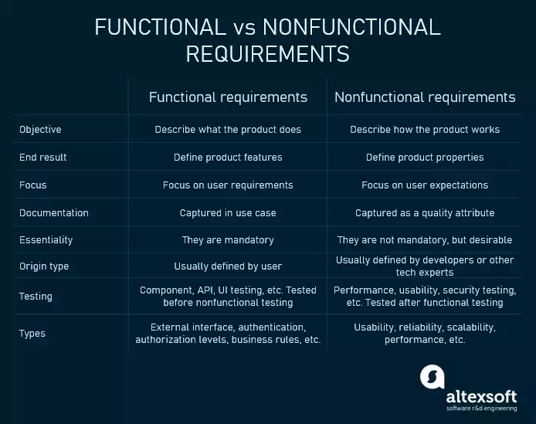

4.3 System Analysis Diagrams
In this section, you will heavily rely on the design paradigm that you defined in Chapter 4. Refer to the section in Chapter 3

4.3 System Analysis Diagrams
- some of the system analysis diagrams considered are as follows;
4.3.1 Use Case Diagram
- Description of the diagram drawn - prose
- The diagram itself
- Each diagram MUST be captioned.

4.4 System Design Diagrams
- Takes the same format as in 4.3 above....

[Check the diagrams provided based on the system development paradigm that has been used -> Classroom, chapter 3]

What type of Database Schema Do we need?
- Logical Database schema - This shows how the real database will be formed by logically setting out how the tables and relationships will be formed.
You know where the tools are, the internet is your oyster.
For Consistency, Use these tools
- Star UML (database schema, class diagrams)
- Visual Paradigm (Other diagrams) - use the offline version (download, use for free for 30 days)
- To avoid watermarks on the document, take screenshots of the drawing
- You can use any other tool of your choice like Ms Visio

Chapter 5: System Implementation and Testing
5.1 Introduction
- Describe and state the sections covered in the chapter - [make a one short paragraph for the descriptions]

5.2 Description of the Implementation Environment

(Hardware)
- The sections should be written in prose
5.2.1 Hardware Specifications
- Specs used in various Hardware [computers and servers, can be in the cloud as well ]---> always discuss and show them in a table.
- Mobile phone, tell us the specs of the phone
- Describe and discuss each and every sensor used, boards used and their functionalities [include if you're using IoT]
- Like, Humidity, Oxygen, BME280 sensor [5.2.1.1-->]
- You can provide images here as well, just one image

5.2.2 Software Specifications
- Define and describe the software required to run your project e.g Android 7+, or Windows server 2020, Windows OS, Linux Box, Mac OS. you should include the versions as well to show the threshold that users should be looking out for. Provide the justification as to why this is needed.
- In case one is using Docker, show why it is needed, npm, composer. [Discuss in detail how they were used to set up and run the projects] -> Add what is relevant to your project.
- In Case of additional software, you may include it here [IoT]
- Applications used in running the projects [sms server, email server, firebase]

(ML)
5.3 Description of the Dataset
- Discuss the dataset, how it was retrieved, analysis of the data in it.
- Discuss, Training data, testing data and Validation data--> Give more information about this data
- Discuss the features and labels as extracted and used.
- Discuss how the features were retrieved, one hot encoding and the reason for this.
- To support your work, provide screenshots of your Jupyter Notebook [the important parts, graphs etc]

5.4 Description of Testing (replace with description of training, evaluations and the metrics used)
- Discuss how testing was done.

5.4.1 [ML]
- Discuss how training was done, mention how you prepared your data and files imported
- you may support this with some screenshots of the code and some of the graphs
- Discuss how models were analyzed and saved [how it was prepared] and graphs analysed
- Did you use 10 fold testing??

5.4.1 [IoT]
- How the setup was done
- How testing was done to confirm the full functionality of the circuits, show more information on the testing of the components.
- Any other modules [WiFi, Sms and etc]
- You can add some of the screenshots here
-

5.4.2 Testing Paradigm
- Discuss the testing paradigm used in details [provide a diagram if possible]
- White box testing
- Black box testing
- Penetration testing
- Unit Testing (provide the sample functions for testing the solutions and core functions in the codebase)
- You can support this with a screenshot of the unit test done
- A combination of any two?
- You need to modify this section based on your project [ML, IoT]

Chapter 6: Conclusion, Recommendations & Future Works
Conclusion
- Summarize the research from the problem, what was initially envisioned to the solution. This is to be done in 1-2 paragraphs at most
- Highlight the key deliverables in this sections

Recommendations
- Explain any challenges you faced and how, if you were to carry out the same research, you would go about it i.e. how best should such a research be carried out

Future Works
- Highlight any areas of research that can be derived from your work
- E.g., If you are working on Classification using ANN, recommendation could be how other algorithms can be evaluated on a similar problem set and compared with what you have.

References

Appendices
Appendix A: Gantt Chart
Appendix B: Github Analytics Report
Appendix C: Interesting Code Snippets (if Any)
Appendix D: User Manual
Appendix E: Marking Guide

Document Submission Guidelines (more guidelines will be shared in class)
Preliminary Pages should be there:
Declaration page with the Student signature
Abstract
Table of Contents
List of Figures/ Tables/Abbreviations/Equations
Definition of Terms
if you have any jargon, technical terms or context specific meaning
Printed and spiral bound
Marking guide at the end of the document.
Formatting: Times New Roman; 12; 1.5 line spacing;alignment-justified
Heading 1s can be aligned center, bold

a supposition or proposed explanation made on the basis of limited evidence as a starting point for further investigation.: "professional astronomers attacked him for popularizing an unconfirmed hypothesis".

